It’s really uncanny after all of these years celebrating Indias 90th birthday … an absolute number! Until recently not many friends (or law enforcement or doctors!) really knew Indias age. I think there were at least 3 different official documents that had different birth years on.

Even on her wedding day to Quentin, Indias birth year was left off the marriage certificate and was only written in once all the guests (who were eager to find out) had left.

You are an extraordinary example of what 90 should look like. You are so glamorous and are so young at heart, you put many 20-year-olds to shame.
2,840,313,600 seconds
47,338,560 minutes
788,976 hours
32,874 days
4696 weeks
1080 months
Or … 90 years

Happy 90th India … or is it ???

Wish you all the best …
Steve & Cindy
xxxx

Photos attached below ….

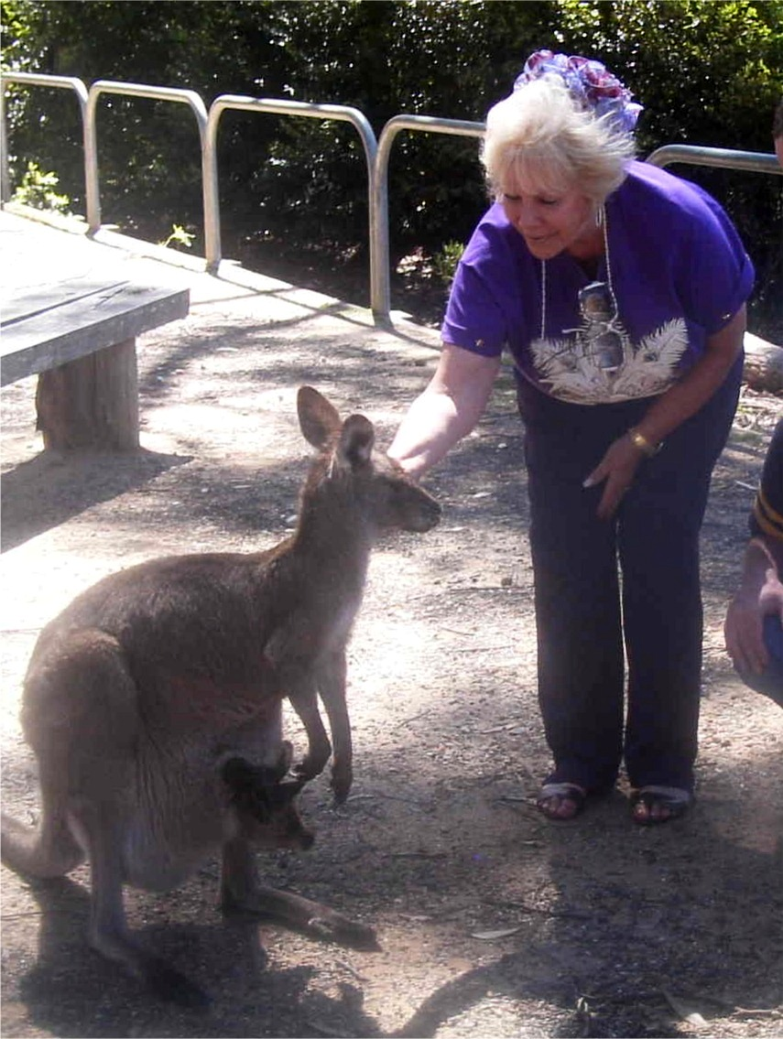
India in Australia – Jan 2000 (aged 50)
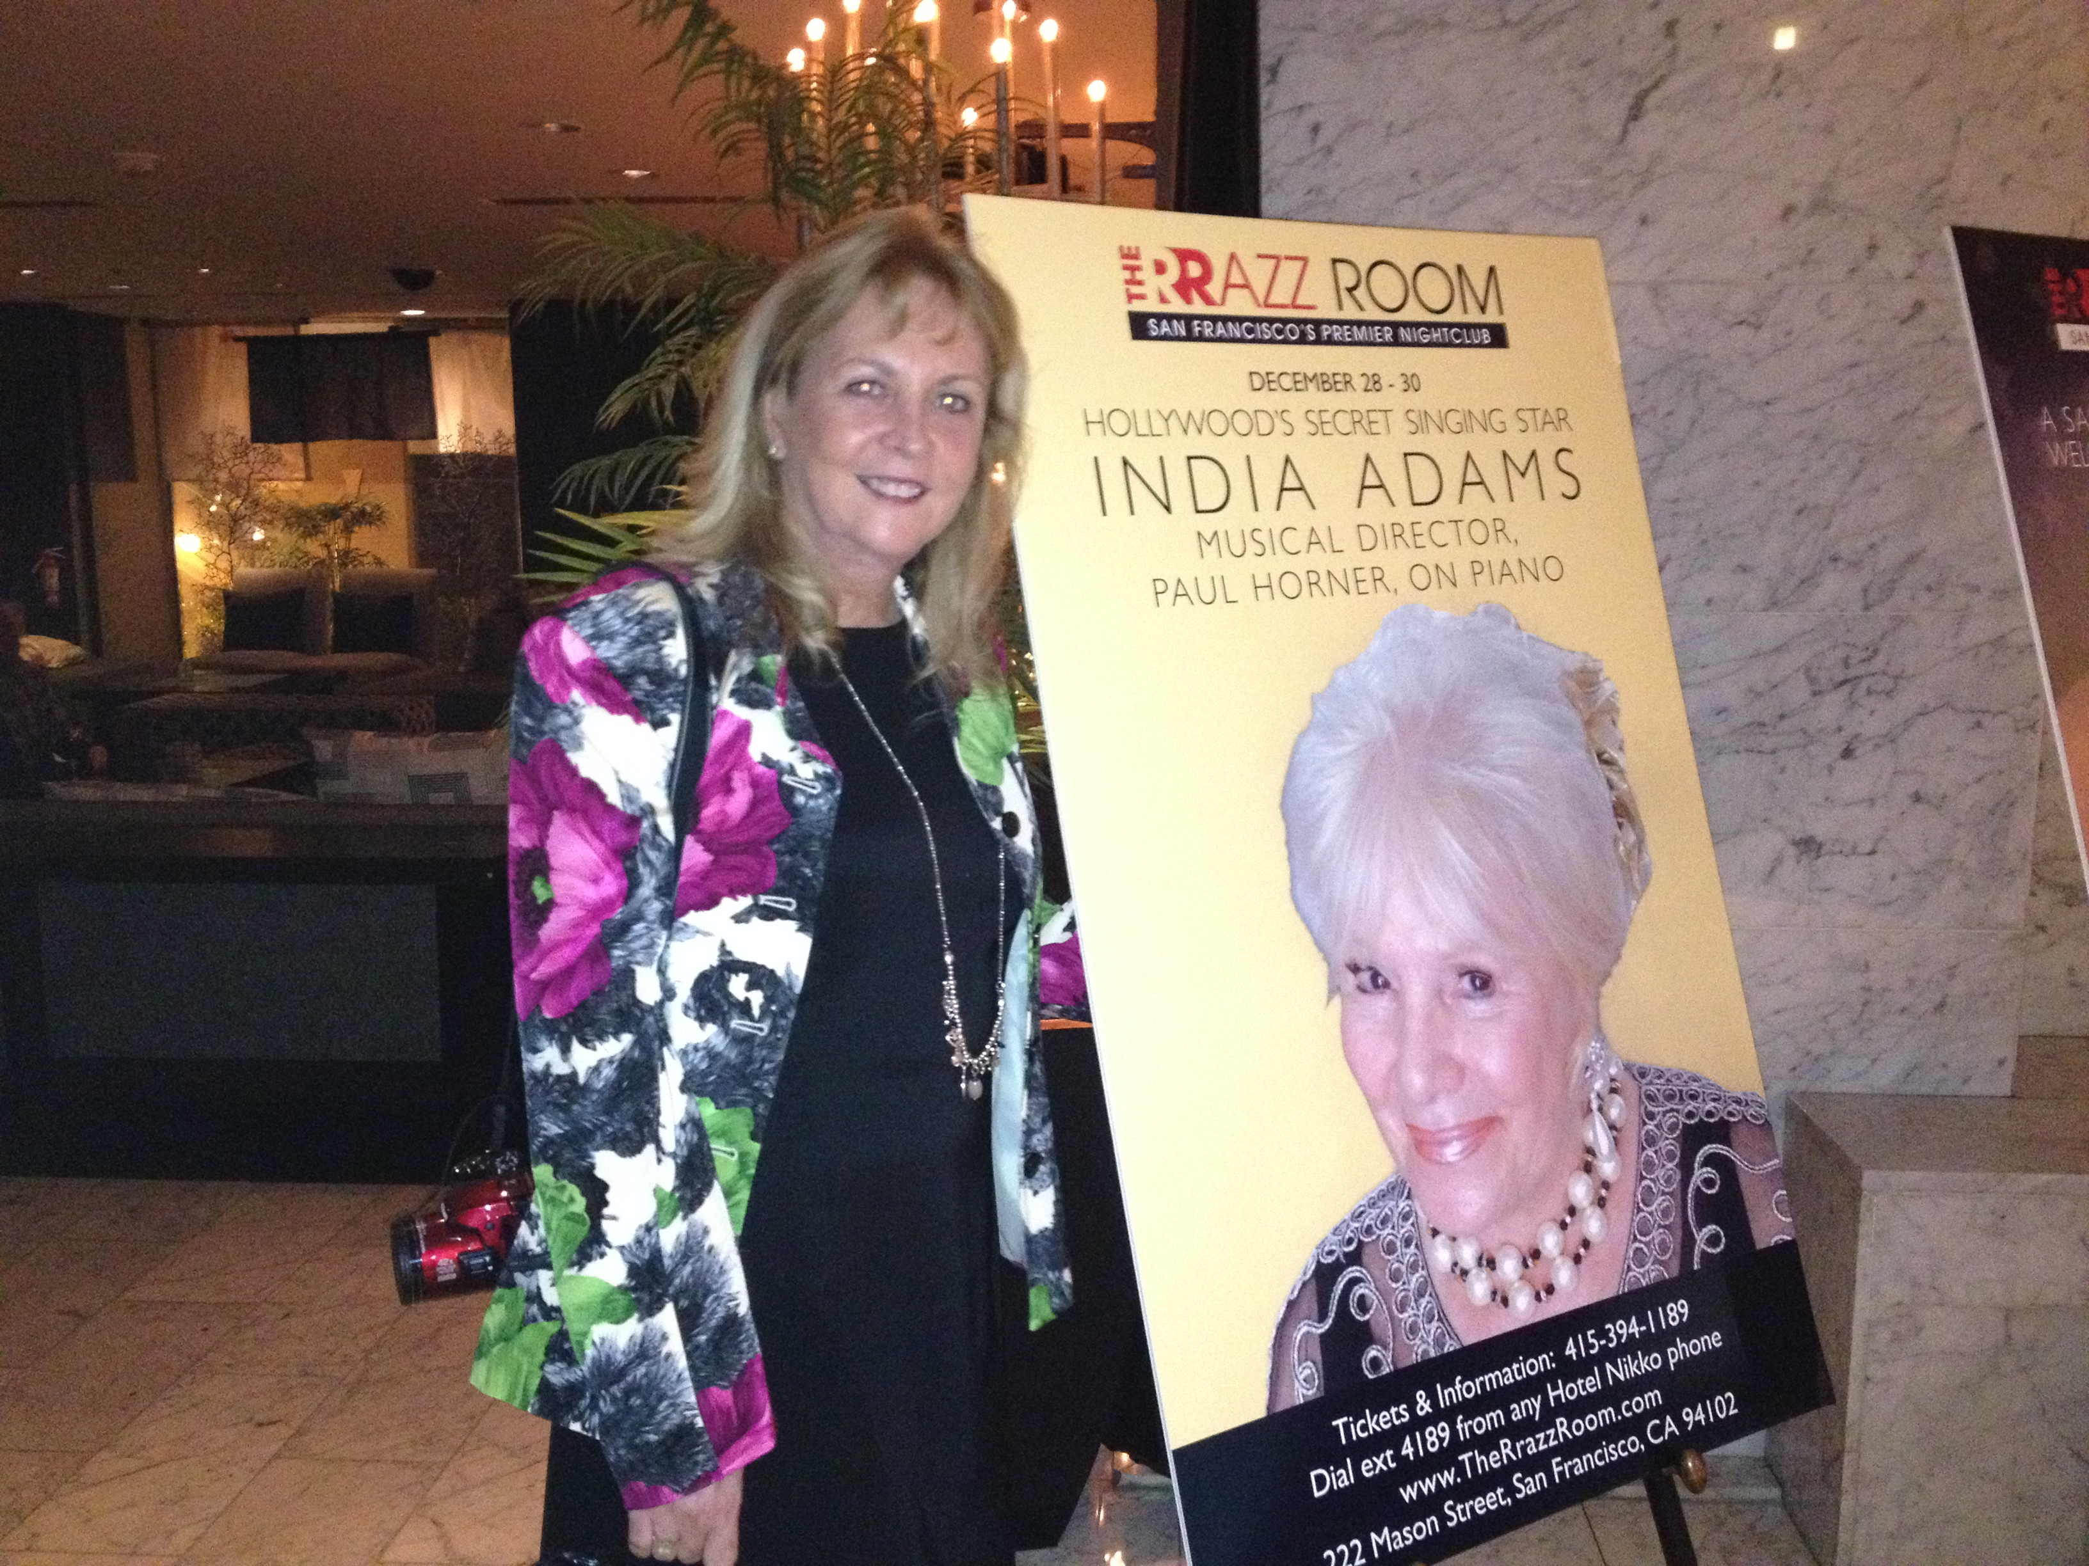
Cindy at Indias show in San Francisco – December 2012 (aged 55)
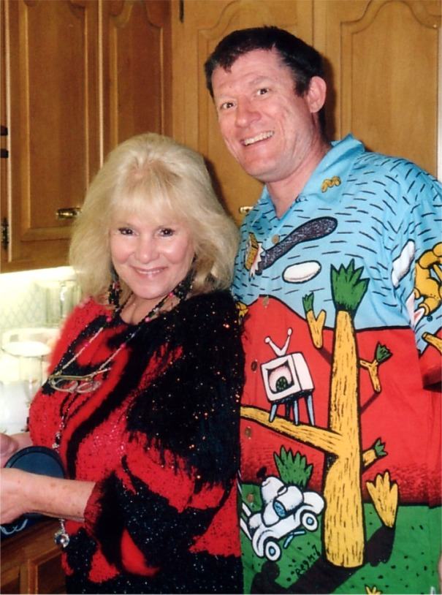
India and Steve – Rancho Street – December 2002 (aged 45)
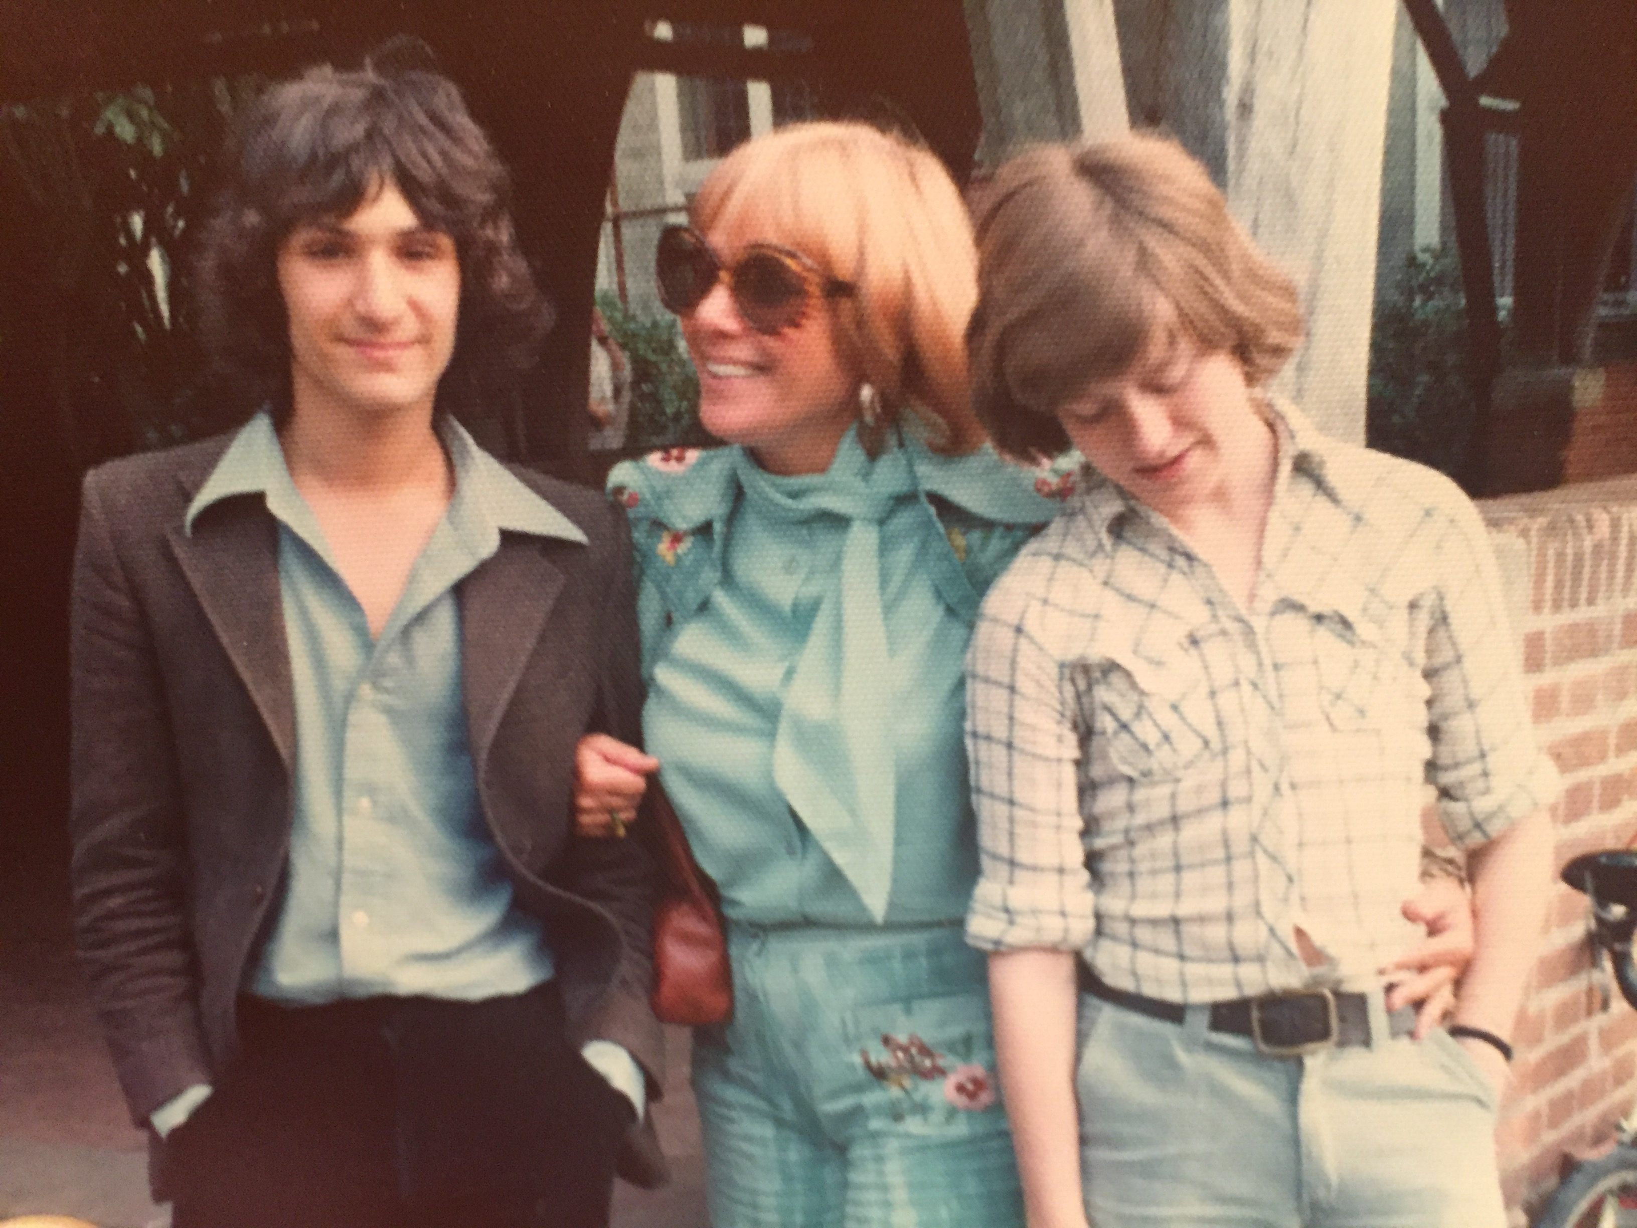
Zane India Steve – Circa 1973 (aged 25)
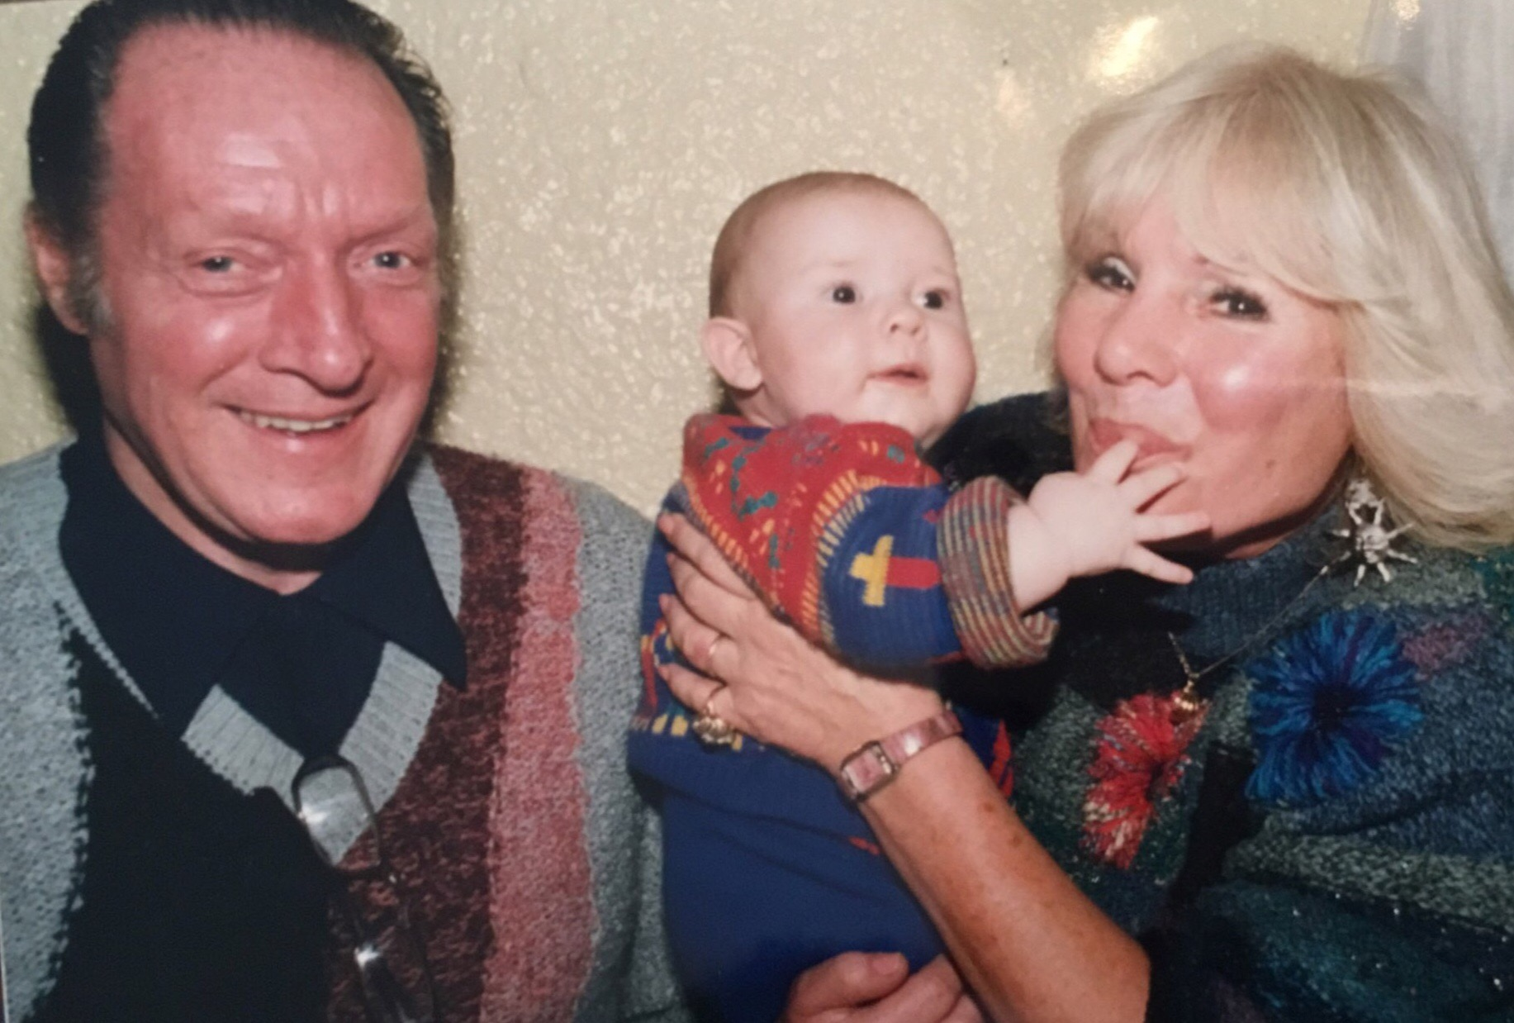
Quentin – Grandson Dean – India – Circa 1992 (aged 32)

